

Name :Muhammad Shaheer
Roll no:20p-0480
Subject :Operating Systems Lab
Lab TASK 2

OS TASK 1

Task-1
Create four .cpp files as follows
- hello-1.cpp
- hello-2.cpp- hello-3.cpp- hello-4.cpp
Run the files separately using common (g++ hello-1.cpp -o hello1) and get the output of each file.
Now
write shell script to execute these files i.e hello1, hello2, hello3
and hello4. When you run this script, you should get the output of all 4
files.
Now add this script in your Dockerfile and build your image.
Command: docker build --name your_name .
Now run the container from the image you just build and you should get the output of all the .c code files.
Command: docker run mylab
____________________________________________________________________________
Create files using terminal:

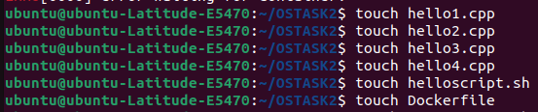
_________________________________________________________________________
now lets write code for all files:
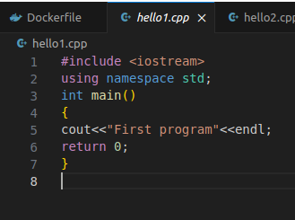
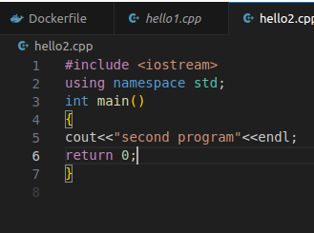

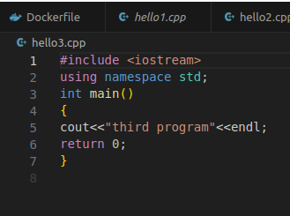
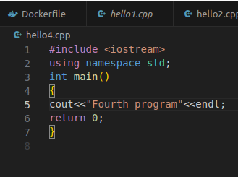

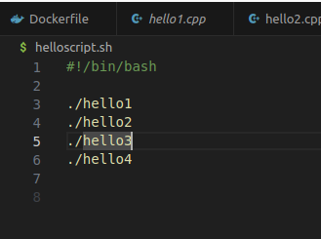
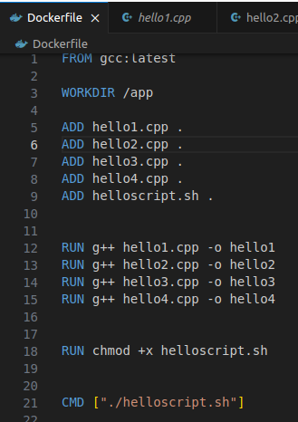

________________________________________________________________________________
Now run files :

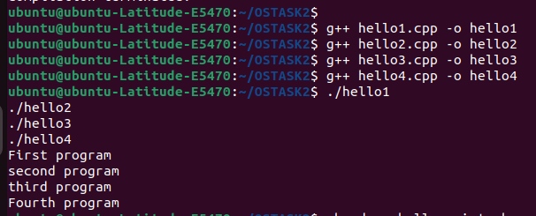

________________________________________________________________________________
Run helloscript file:

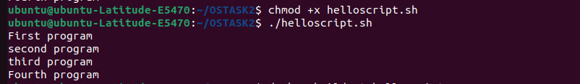
________________________________________________________________________________
Now build image:
Problems facing:
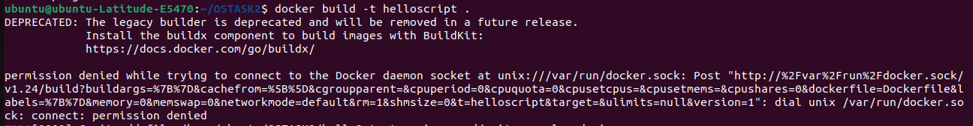
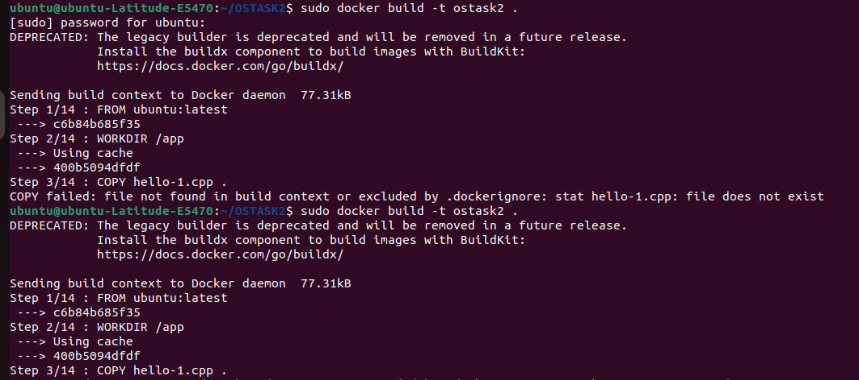
________________________________________________________________________________

So after taking many attempts:

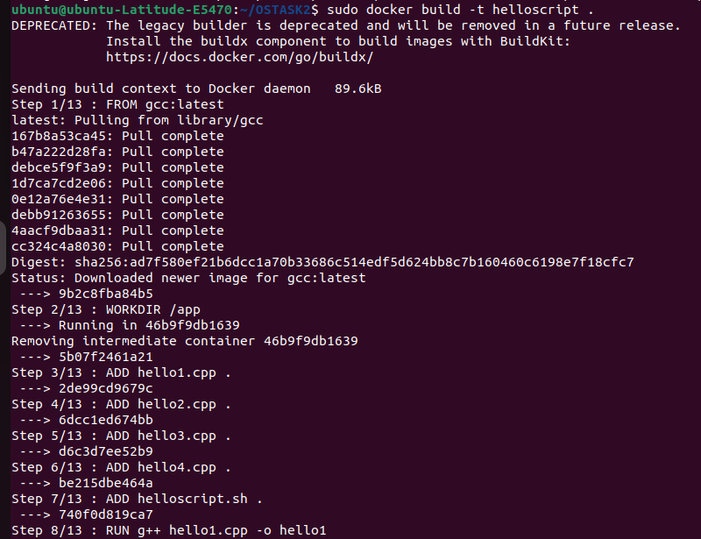
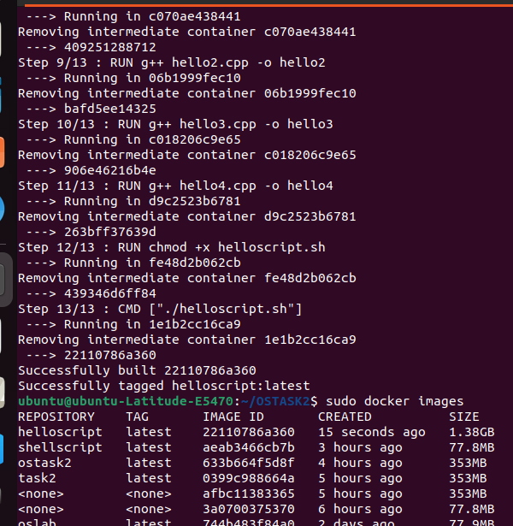
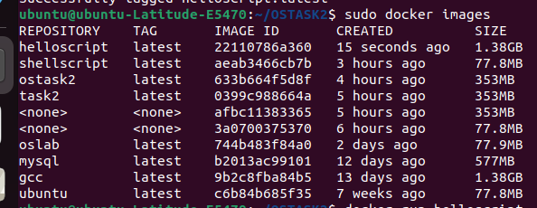
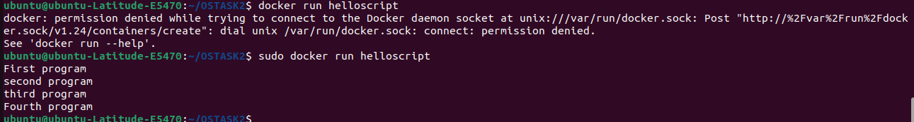
Hence final result is:

OS TASK 2

TASK 2:

task is you have to print the Even numbers from range 1 to 20 using docker containers. Like
when I run container it should print the table as follows. And even numbers should be calculated using Shell Script only.
Hint: write shell script to print even numbers once done create your Dockerfile and run you .sh script inside the conatiner.
Even Numbers are:
2
4
6
8
10
12
14
16
18
20
________________________________________________________________________________

Create files and folder using terminal.
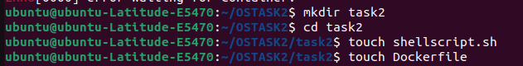
Here our folder looks like:

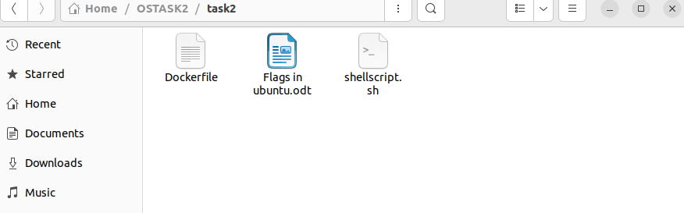

Now write code content in files:

Code for shellscript.sh
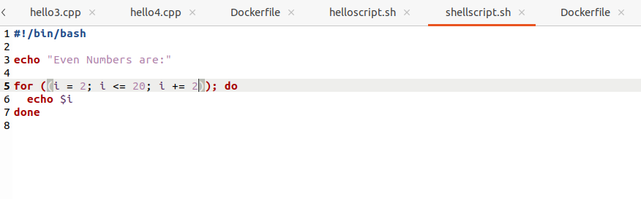
Code for docker file:

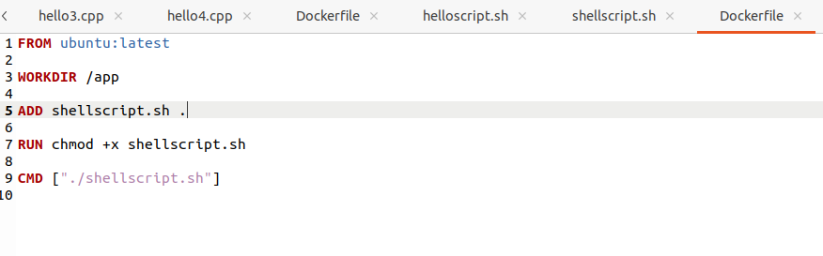

Now write some commands on terminal.
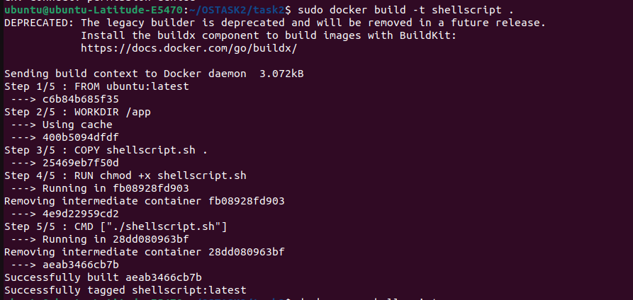

Now let see our docker images:

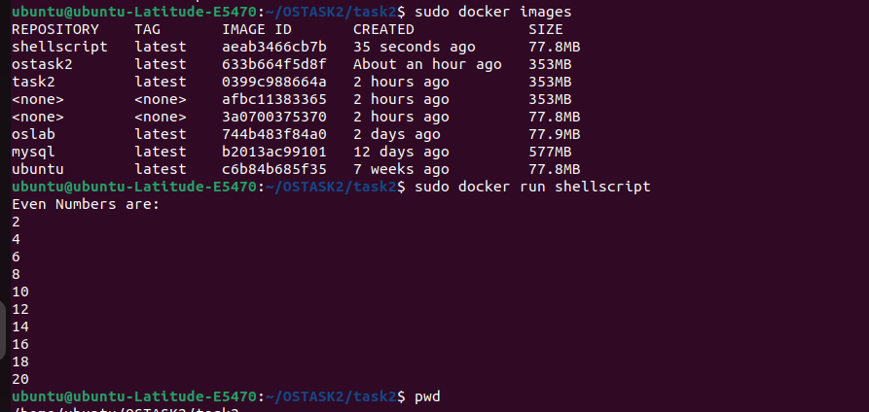

After running this commands we get our result.

ERRORS Facing :
